Independence Neighborhood – Homestead Poolhouse & Amenities
Elizabeth, CO

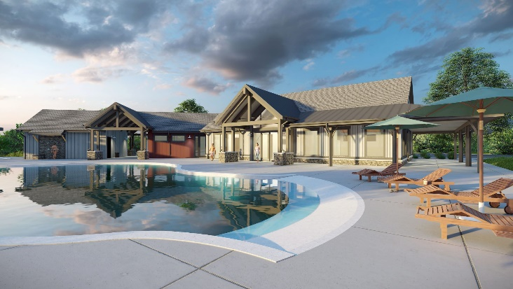
Project Details
Description: 6,000 sf pool & deck
3,875 sf poolhouse & fitness center
Shade structures, landscaping & trail systems
Owner: Craft Companies
Architect: KGA Studio Architects
CM/GC: Waner Construction
Budget: $2.6M
Completion: N/A

Project Description
Homestead is an amenities complex designed to service residents of the Independence neighborhood in Elizabeth, CO. It consists of a pool and pool deck, 3,875 sf new build poolhouse with fitness, and accompanying fine grading, landscaping, trails, and shade structures. The rehabilitation of several historic site buildings and barns was contemplated as part of the full site plan.
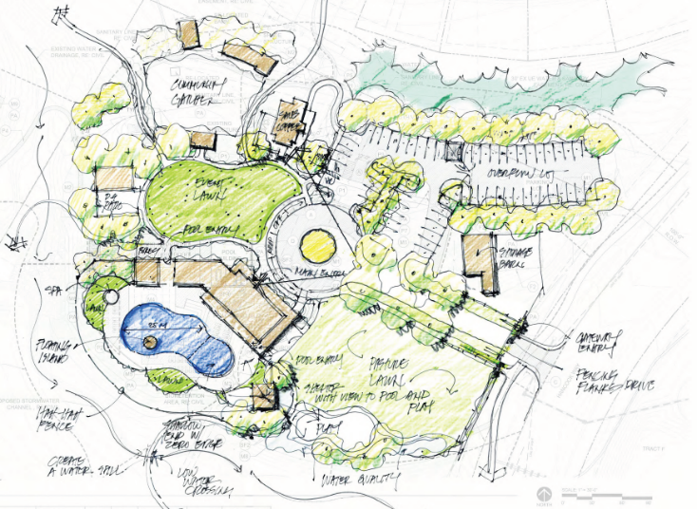
Scope of Services
SII was engaged to manage the design and contracting for the project. Eric Shafran served as the Principal in Charge, Chris Landry served as Project Executive and Cord Green was the Project Controls Manager for the duration of the design and contracting and all were charged with overseeing and managing virtually all aspects of the project. Responsibilities included:
- Ongoing development and management of the complete project budget, including monthly management, tracking, and reporting to the client of all change orders, contingency usage, budget transfers and commitment levels
- Close coordination with project ownership to develop a strategic, cost-effective, and site master plan
- Management of the RFP, interview, selection, and contracting for both the architect and general contractor
- Coordination with vendors for fitness FF&E design, pricing, value engineering, and selection
- Developed overall project schedule, that included design, preconstruction, construction, utility, and FF&E milestones
- Oversight of the architectural design team and close tracking of their progress towards both achieving the Homestead’s programmatic and aesthetic/architectural goals, as well as construction cost targets
- Monthly construction draw reviews and daily monitoring and negotiation of potential and realized construction change orders
- Negotiation, engagement and management of contracts with secondary consultants in the fields of geotechnical, survey, network and security design, audio/visual and signage design

